A partner you can approve with confidence.
Certified management systems, ethical business practices and a confidentiality-first way of working, so your procurement, quality and legal teams can say yes.
Introduction
Boiler circulation pumps sit in critical plant, and the companies that service them are chosen carefully. Behind every repair is a question of trust: Will the work be done to a controlled standard? Will our drawings and customer data stay private? Will this supplier behave properly in international business?
This page sets out how DEI VOX answers those questions. It covers our certifications, our quality system, the rules we work to, and the way we protect your information and your customer relationships.
Certified Management Systems
Heading: Three international standards
Standard | Covers | What it means for you
ISO 9001:2015 | Quality management | Controlled processes, records and continual improvement
ISO 14001:2015 | Environmental management | Responsible handling of waste, materials and workshop impact
ISO 45001:2018 | Occupational health and safety | Safe working practices for our people and for on-site work
Certificate numbers and validity: [add]
Buttons: View Certificates (PDF)
How Our Quality System Works
Quality built into every job
- Documented procedures for receipt, inspection, repair, testing, packing and dispatch
- Document control, so the right version of every procedure and drawing is used
- Calibrated measuring and test equipment, with calibration records kept
- Material and component traceability, linking parts to their source and to the job record.
- Controlled processes for special work, such as welding, machining, balancing and testing, by trained personnel.
- Non-conformance and corrective action, so problems are recorded, investigated and fixed at the root
- Internal audits and management review, to keep the system working.
- Customer feedback, collected and acted on
- Records retention for 10 years, so job history is available for later outages and audits
Link: See how we test and document every job → Testing and Quality Assurance
Supplier and Subcontractor Control
When we use outside suppliers, for example for raw materials, coatings, special testing or certain machining, we control them:
- Suppliers are approved and reviewed against defined criteria.
- Incoming material and services are inspected or verified.
- Certificates and test records are requested where the job requires them.
- Critical work stays under our supervision and responsibility.
- We tell you in advance if any part of your job needs to be performed outside DEI VOX, where your contract requires it.
Health, Safety and Environment
Our ISO 45001 and ISO 14001 certifications shape our daily work.
- Safe handling of heavy rotating equipment, lifting and testing
- Defined workshop safety procedures and protective equipment
- Safe working plans for in-situ and on-site jobs
- Controlled handling and disposal of oils, chemicals and waste
- Training and incident reporting
- Respect for environmental rules that apply to our workshop
If your customer’s site requires specific safety documents, such as method statements or risk assessments, tell us early and we will prepare them.
Ethical Business and Legal Compliance
How we do business
We conduct business honestly and lawfully, and we expect the same of our partners
- Anti-bribery and anti-corruption: we don’t offer, give or accept bribes or improper payments, and we keep clear, honest records.
- Code of conduct: a written code covers conflicts of interest, gifts and hospitality, and fair dealing.
- Export controls and sanctions: we comply with the trade laws that apply to our work and our shipments, and we may decline or delay an order where the law requires it. We ask partners to give accurate information about end users and destinations.
- Honest representation: we describe our capabilities, makes and results accurately, and we don’t claim approvals, certifications or experience we don’t have.
- Fair competition: we compete on quality, service and price.
- Labour and ethical practice: we respect applicable Indian labour laws and treat our people fairly.
- Concerns and reporting: anyone may raise a concern about our conduct at sales@deivox.co.in, and we will review it fairly and confidentially.
Independence and Trademarks
DEI VOX is an independent service provider. We are not affiliated with, endorsed by or sponsored by any pump or motor manufacturer. Manufacturer names and series designations on this site are trademarks of their respective owners and are used only to identify the equipment we service.
We do not use OEM logos, and we do not present our parts or services as OEM-supplied unless they are.Confidentiality: Our Standing Commitments
Data Protection
We handle personal data, such as contact details and enquiry information, in line with our Privacy Policy and applicable data protection law, including India’s Digital Personal Data Protection Act, 2023.
Links: Privacy Policy → · Cookie Notice →
Information Security
We protect your information with reasonable technical and organisational measures:
- Secure, access-controlled storage of job files and drawings
- Strong passwords and, where possible, two-factor authentication
- Regular backups
- Restricted use of personal devices and removable media for customer data
- Prompt reporting and handling of any suspected incident
If your company requires a security questionnaire, we are glad to complete one.
Documents Available on Request
Supplier information pack
For supplier approval, we can provide
- Company registration details, including GSTIN and CIN
- ISO 9001, 14001 and 45001 certificates
- Quality policy and HSE policy
- Code of conduct and anti-bribery statement
- Facility and equipment list
- Bank and tax details for onboarding
- Insurance certificates
- Completed customer supplier questionnaires
Audits and Customer Visits
We welcome supplier audits and visits to our workshop. Remote audits by video are also possible. We can arrange customer witness of testing and inspection, as described on our Testing and Quality Assurance page.
Link: Plan an audit or visit → Contact
15. Frequently Asked Questions
Which certifications do you hold? ISO 9001:2015, ISO 14001:2015 and ISO 45001:2018. Certificates are available to view and download.
Can we audit your workshop? Yes. We welcome on-site and remote audits, and we can agree a plan with you in advance.
Where can I report a concern? Email: sales@deivox.co.in We review concerns fairly and confidentially.
16. Closing Call-to-Action Band
CTA Button: [Ready to approve DEI VOX as a supplier?] | [Subm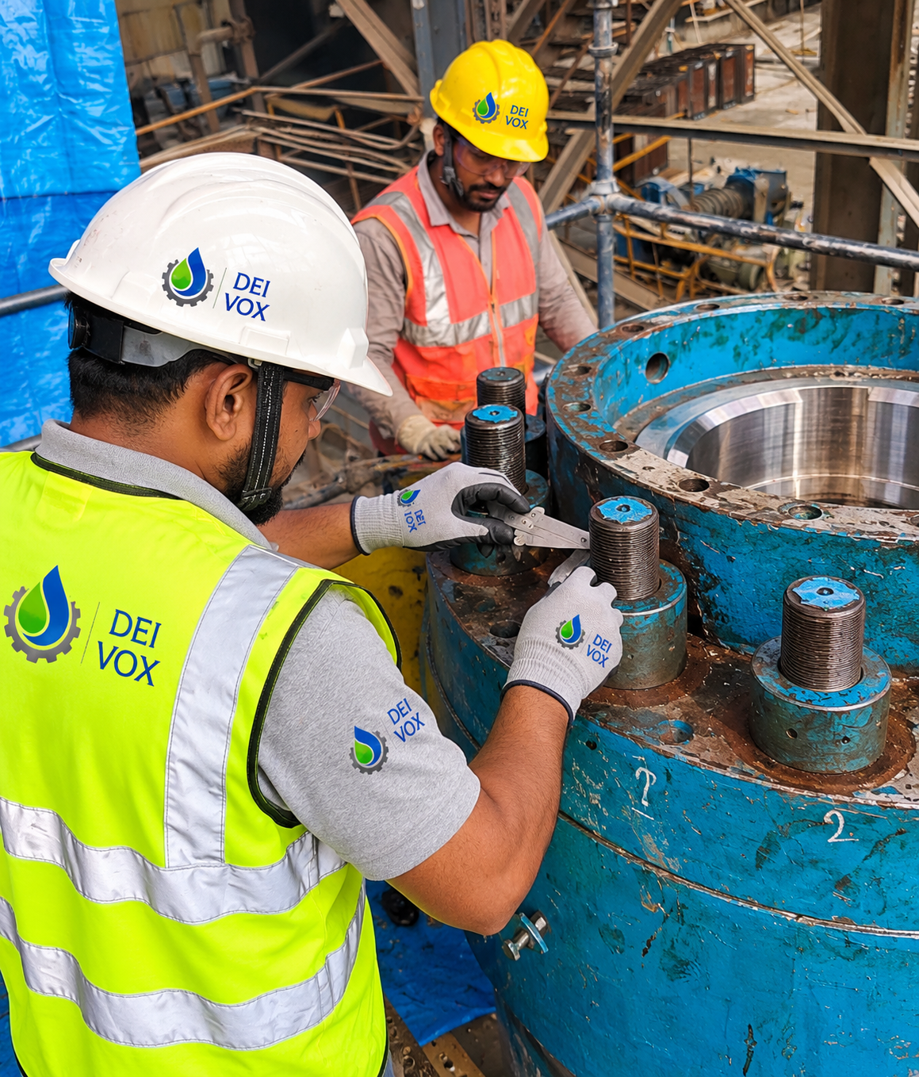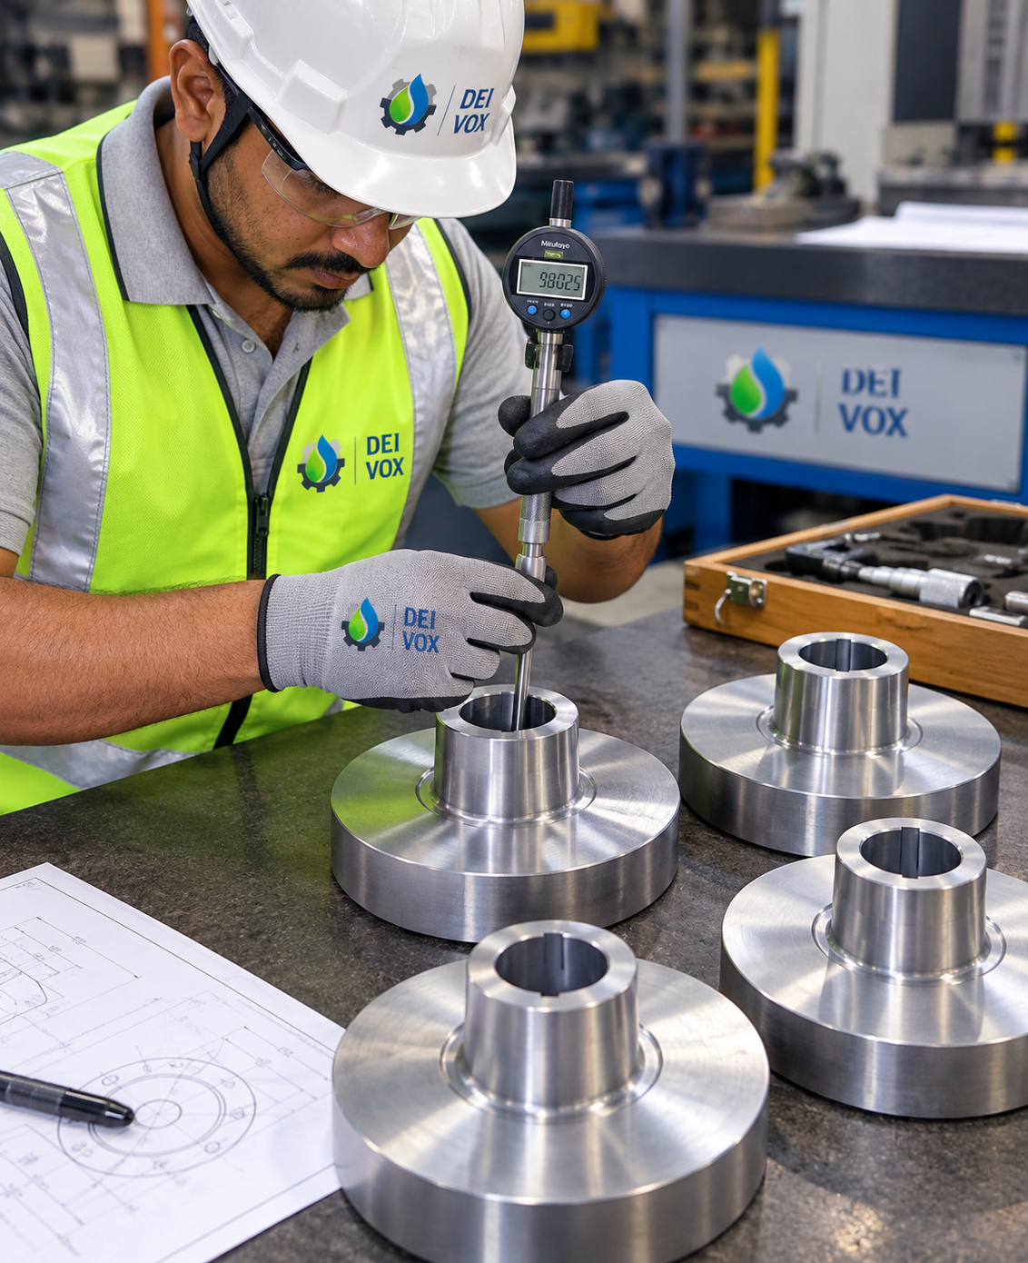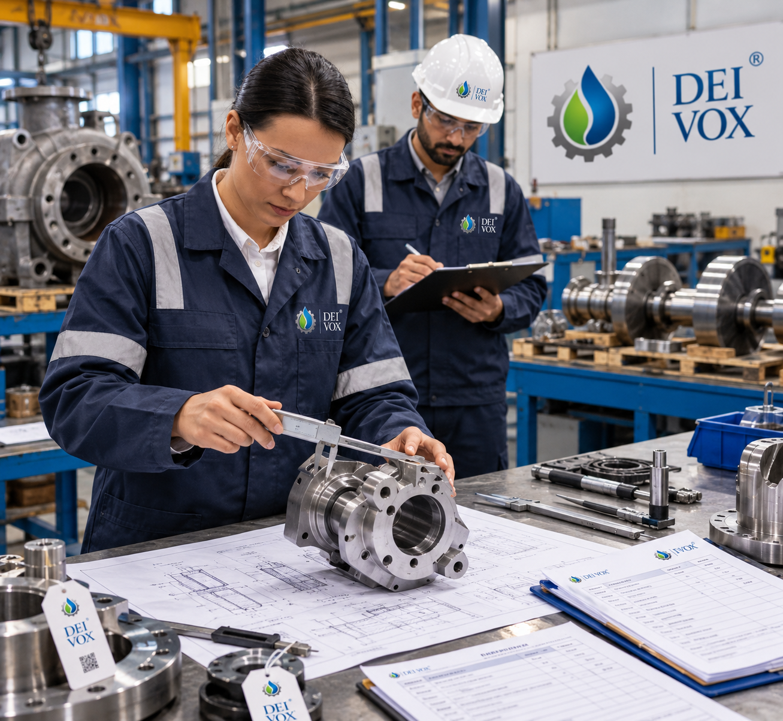it an RFQ]

